**DATABASE MANAGEMENT SYSTEM LAB SESSION 2**

**Name : Ragini Singh**

**Cohort : Jensen Huang**

**Roll No: 150096724023**

**Subject : DBMS LAB SESSION**

**Date: 28/01/2025**

**Time: 4:00 to 5:15**

**Set B**

**Part 1: Database Creation and Table Definition (DDL)**

**1. Create a database named ‘Hospital;**

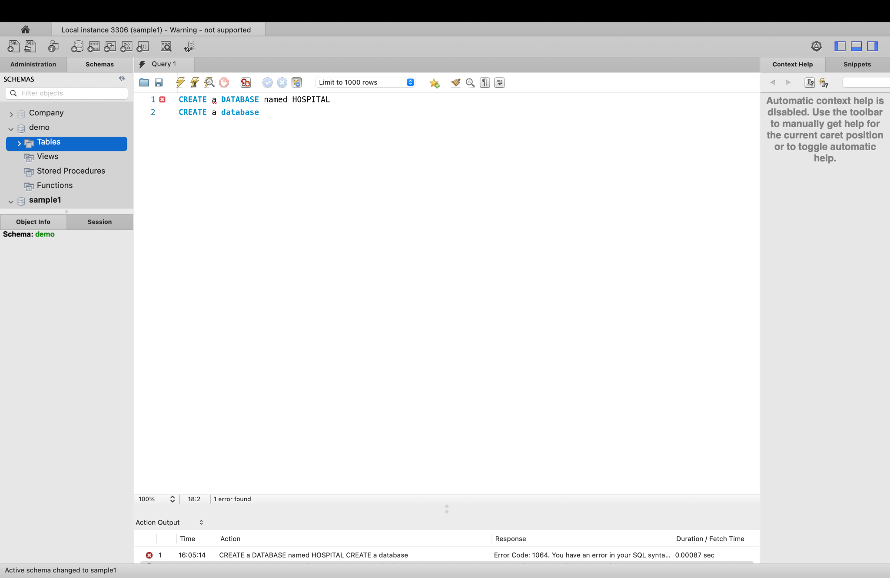

**2. Create a table named ‘Patients’ within the ‘Hospital’ database with**

**following columns:**

**a. patients_id, fname, lname, dob, gender, contact_no (make columns follow**

**appropriate data type, constraint )**

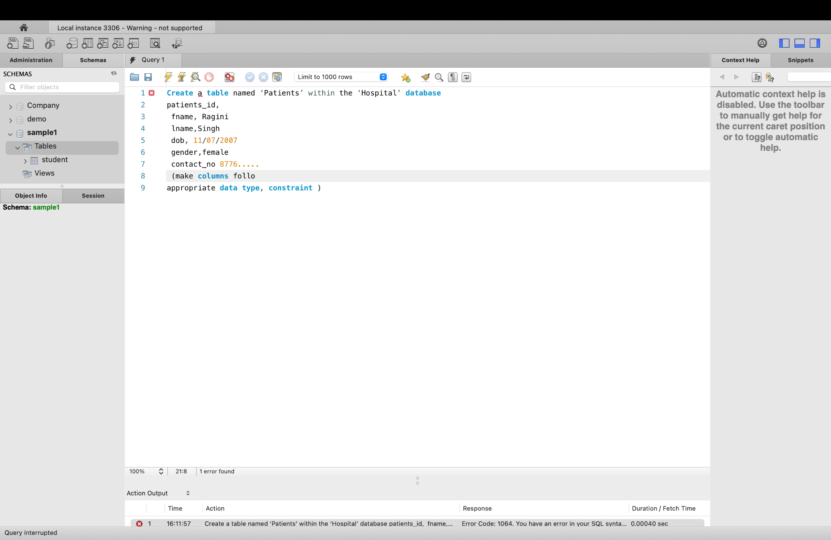

**Part 2: Data Insertion**

**(DATA INSERTION DML )**

**1. Insert at least 10 sample records into the "Patients" table with appropria**

**values for each column.**

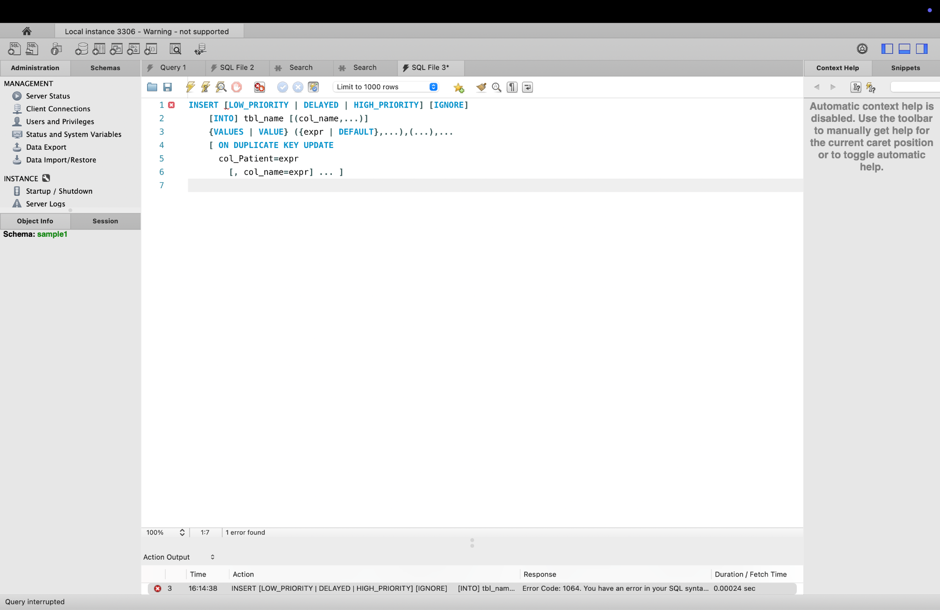

**Part 3: Data Retrieval and Querying**

**(DQL)**

**1. Write a query to display the unique birth years of all patients in ascending.**

**order.**

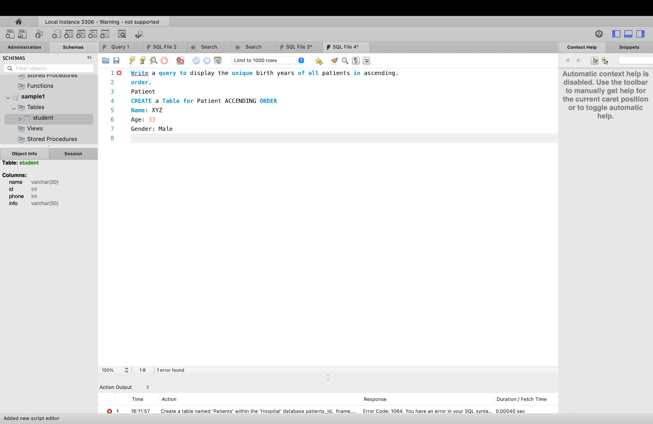

**2. Write a query to display the unique first names of patients that appear only**

**once at the table.**

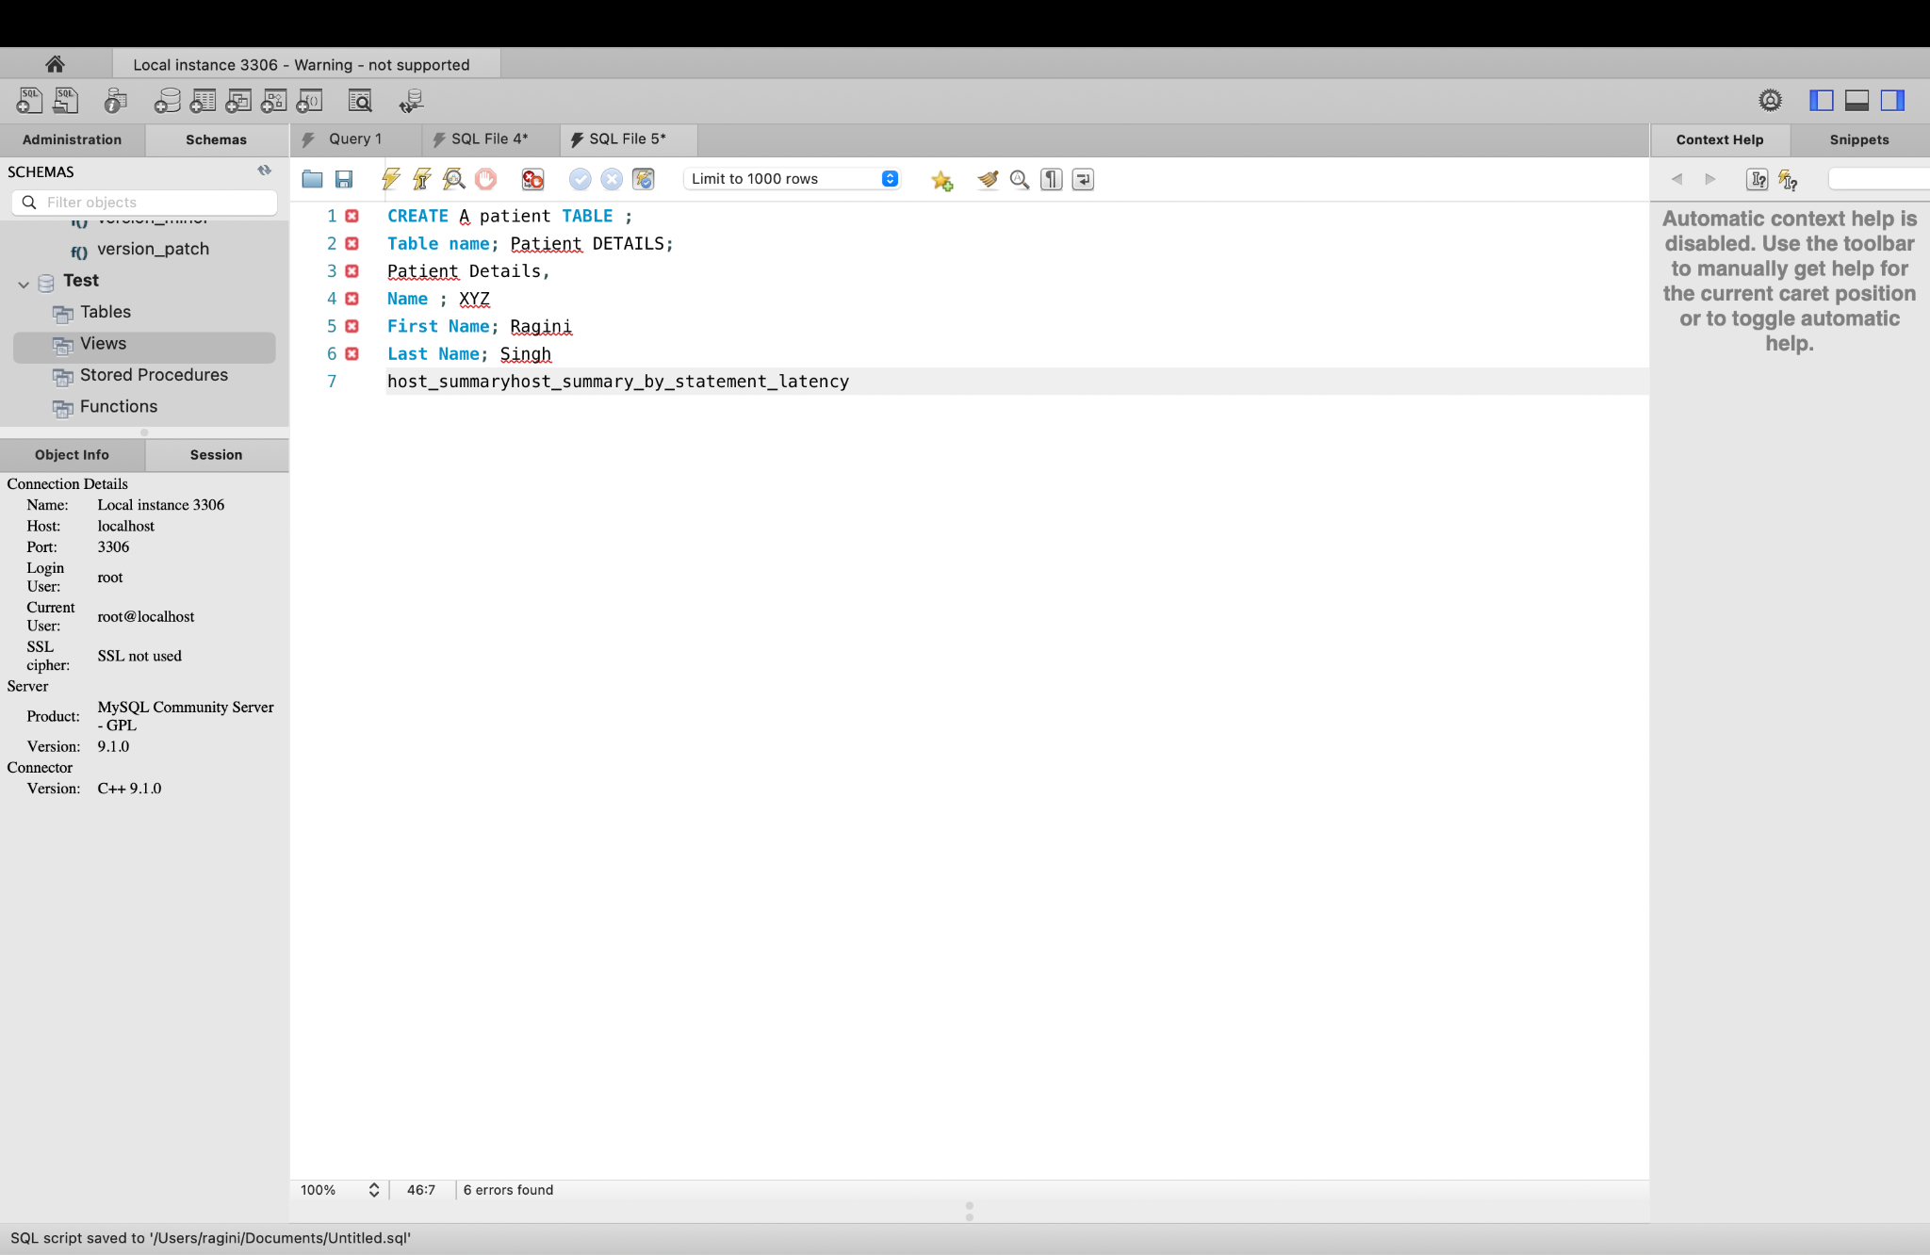

**3. Write a query to display the patients_id and fname of patients where their**

**fname starts and ends with 's' and has a length of at least 6 characters.**

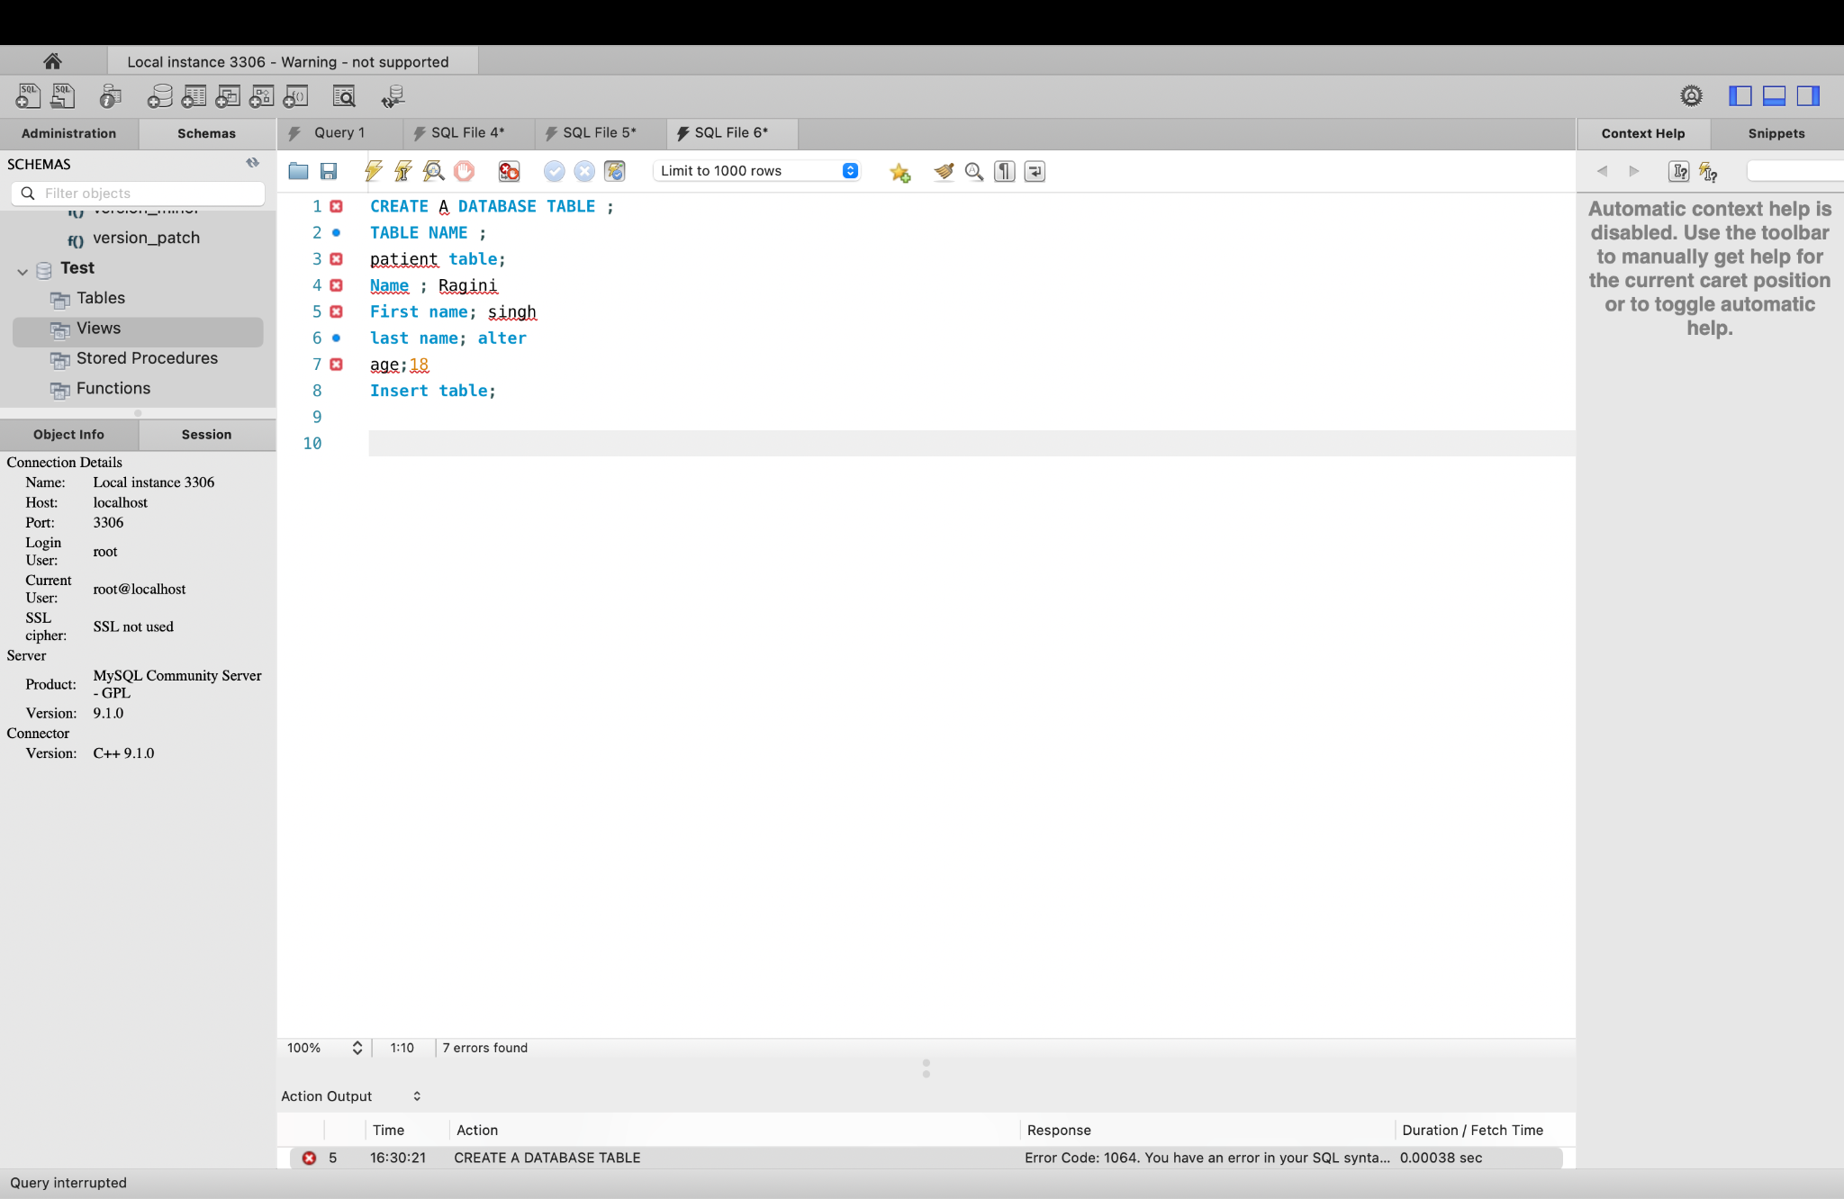

**Part 4: Debugging**

**1. Identify and correct any errors in the following SQL statements;**

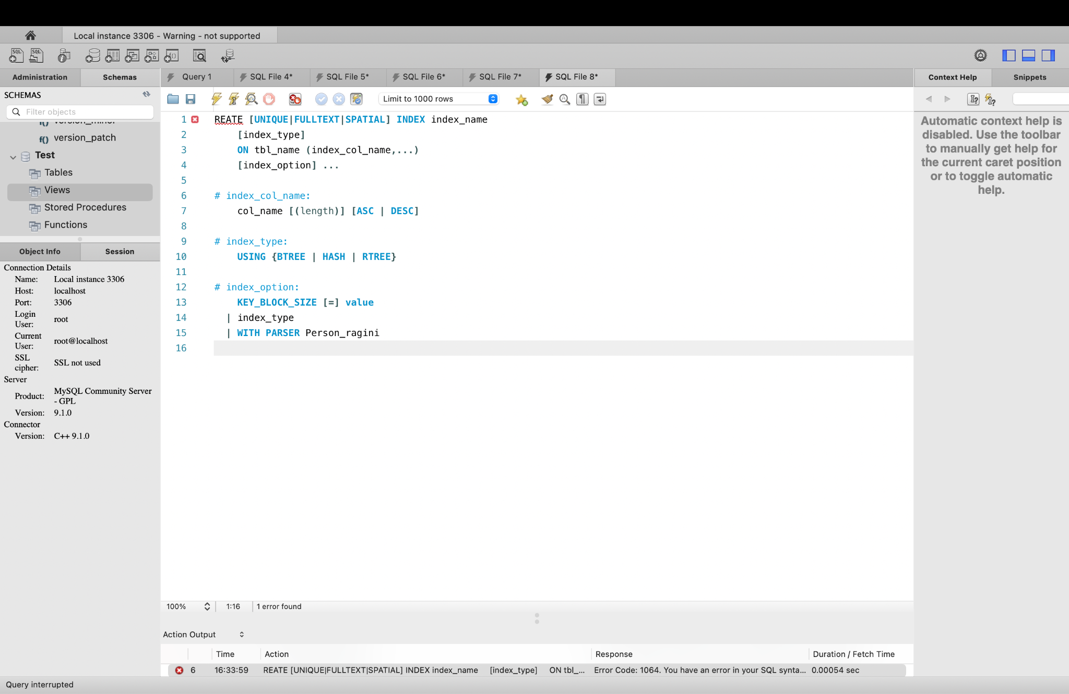

**2 Correct: if you find any error modify the statement accordingly to ensure it excutive correctly**

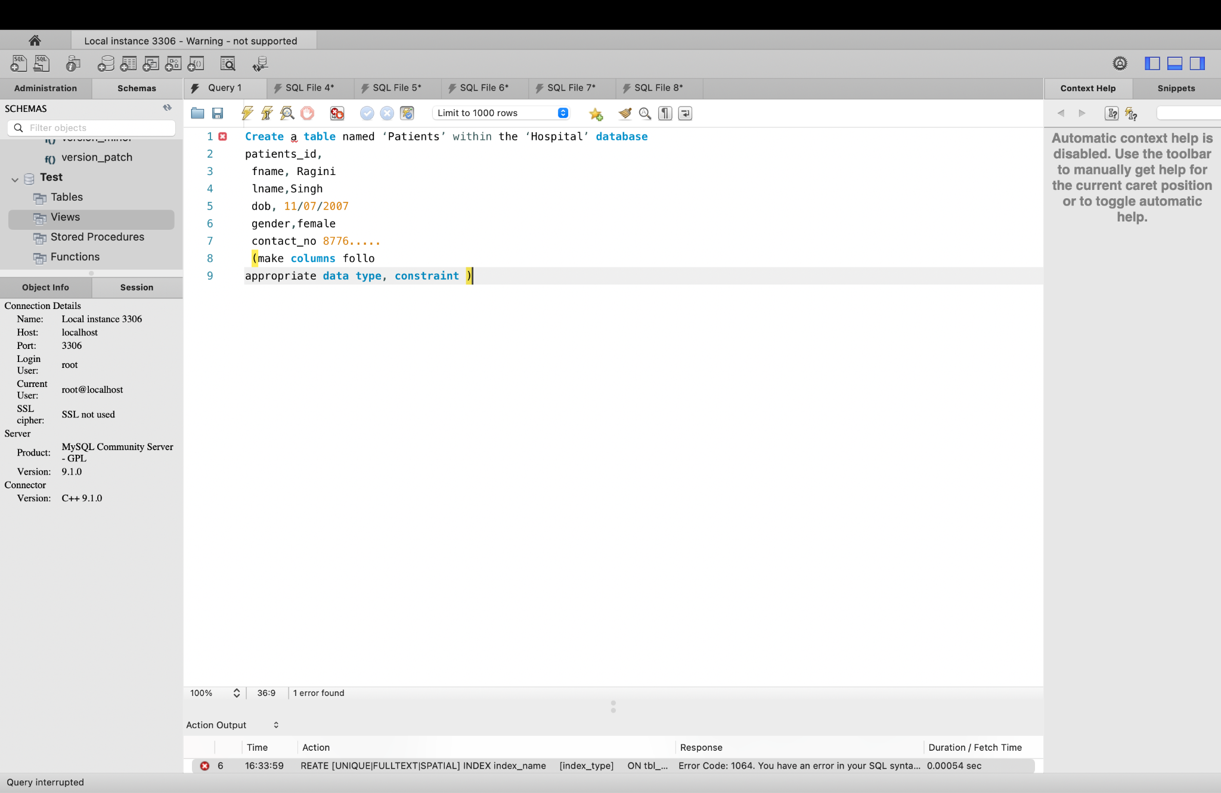

**3.Explain : Briefly Explain the type of error you idendifier and how your correction resolves it ??**

**Statement 1:**

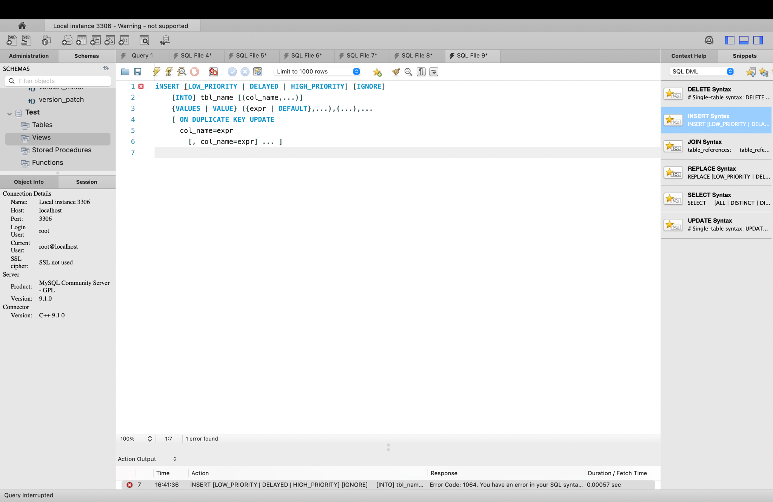

**Statement 2** 